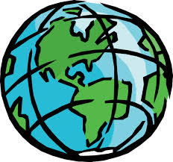
Name:

Answer the following questions-
- Describe in your own words the location of Nicaragua on a map. Mention the continent it is located on and the position of the country with respect to the neighboring countries.

- Describe in your own words the location of Ecuador on a map. Mention the continent it is located on and the position of the country with respect to the neighboring countries.

- Answer the following questions in complete sentences.

  - What is the capital of Bolivia?

  - On what continent and in what country is Caracas?

  - On what continent is El Salvador?

  - What are the three Spanish speaking Islands?

  - On what continent and in what country is Montevideo.

  - How many Spanish speaking countries are in Central America? What are those countries?

  - How many Spanish speaking countries are there in the world? List them.

  - Which Spanish speaking countries are in Europe?

Now that you are done, you can play some review games! Before you log onto the following websites, remember, there are other countries in Central and South America where Spanish is not the official language. Use the map below as a reference while you are taking the quizzes! Good luck!
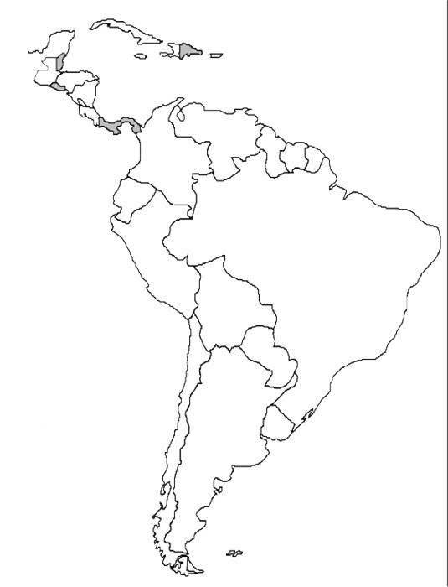
- Do you know your Spanish speaking countries? Start with this link to quiz yourself on the location of these countries. Once you have gotten 100%, call the teacher over to initial your paper so you can move on to the next game.
http://www.purposegames.com/game/spanish-speaking-countries-quiz

Countries Quiz ________

- Click the link below to play a different game. Start with the countries tutorial if you need it, if not, jump right into level 1. Don’t forget to show the teacher your score! Once you have completed the countries quiz, move on to the Capitals quiz.

http://www.sheppardsoftware.com/South_America_Geography.htm

Countries Level 1 ________ Capitals Level 1 ________

Feel free to continue to the intermediate and advanced quizzes if you feel ready!
- Move on to the final link. When you get 100% on the quiz, email the results to your teaching by clicking the button below that says “Email quiz results.”
http://www.123teachme.com/games/drag_n_match/category/countries_quiz

- Now that you have completed all the activities, you can choose which quiz you would like to go back and play. Have fun!

