¿Cómo se pronuncia? (How is it pronounced?)

In Spanish, there are basically nine letters whose pronunciations need special attention:
j, h, b, v, g, c, ch, ll, ñ

- j: make a strong h sound coming from the throat
- h: it is not at all pronounced in Spanish
- b: as we are used to pronounce it in English if it is the first letter of the word (lips touch each other). If b is not the first letter of the word make a sound as if you are going to say "b" but don't touch the lips with each other
- there is no v sound in Spanish. When you see "v" in a word, apply the rules for the pronunciation of "b". (see 3)
- g: if "e" or "i" follows "g" then it is pronounced as j in Spanish (example in Spanish: general)
if "a" or "u" or "o" follows "g" then it is pronounced as guitar in English (examples in Spanish: gorila, guitarra)
6. c:
if "e" or "i" follows c, then it is pronounced as "z" (ex. cinko)
if "a", "o", "u" follows c, then it is pronounced as "k" in kilo in English (ex. casa)
7. ch: pronounce it like you pronounce chair in English.

8. ll: make "y" sound

9. ñ: make an n-y sound one after the other. (If on the keyboard there is no ñ letter, it is written as ny)

Seseo, ceceo and distinction…or why Spaniards “lisp” and Latin Americans do not
One of the questions frequently posed by students of Spanish concerns the so-called “lisp” that can be heard from most, if not all, Spaniards when speaking Spanish: Why do Spaniards “lisp” (and some seemingly more than others) while Latin American Spanish speakers do not?
There are three important concepts that must be understood in order to answer this question: seseo, ceceo, and distinction.
“Seseo” (pronounced “seseo” in both standard Castilian and Latin American pronunciations) is the word used to describe the pronunciation of the letter “s” in all positions, the letter “z” in all positions, and the letter “c” before “e” or “i” (aka as the “soft” c) as a voiceless alveolar fricative. This variant is standard in Latin America and can be found in the Canary Islands, as well as in some parts of Andalusia.
“Ceceo” (pronounced /seseo/ in Latin American Spanish and /θeθeo/ in Castilian Spanish) is the word used to describe the pronunciation of the letter “s” in all positions, the letter “z” in all positions, and the letter “c” before “e” or “i” (aka as the “soft” c) as a voiceless corono-dentoalveolar groove sibilant. Though this sound lacks an official symbol in the International Phonetic Alphabet, it is usually represented by either [s̄] or [θṣ]. This sound is unique to certain areas of Andalusia.
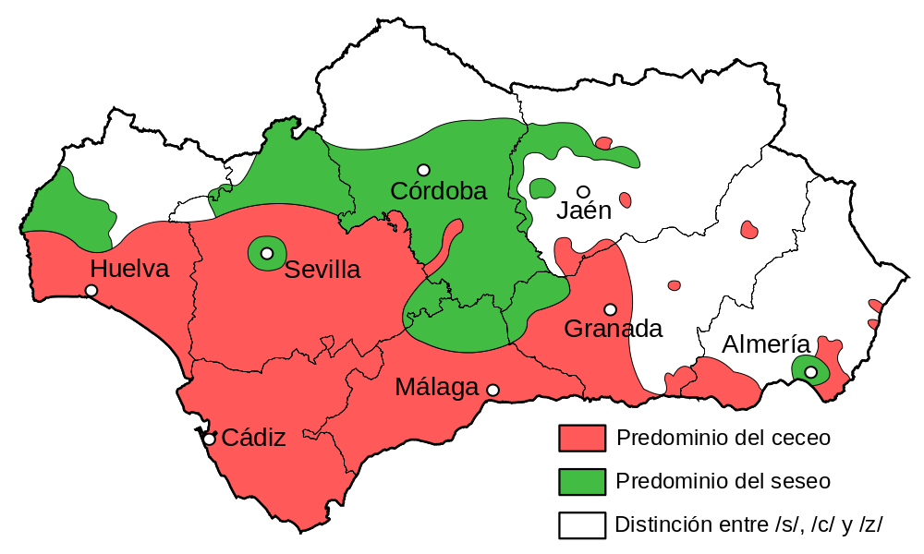
Modern distribution of seseo, ceceo and distinction in Andalusia.
Finally, “distinction” is the maintenance of the phonemic contrast – the differentiation in the pronunciation – between the letter “s” in all positions (pronounced as either an apico-alveolar retracted fricative (chiefly northern or central Spain) or lamino-alveolar retracted fricative (remaining areas)) – and the letters “z” in all positions and “c” before “e” or “i” (aka as the “soft” c) as a voiceless interdental fricative. This pronunciation is considered standard Castilian Spanish and is the basis for Spanish orthography.
The answer to our question of why Spaniards lisp and Latin Americans do not is tied closely to the history of Spain’s exploration of Latin America.
At the start of the century that saw Columbus reach America, Spanish had eight different sibilant phonemes. By the sixteenth century, they gradually began to merge and eventually simplified into three, two (the third was the sound represented by the letters “j” or “g” before “e” or “i”, and is not relevant here) of which corresponded to the letters “s” in all positions, the letter “z” in all positions, and the letter “c” before “e” or “i”. This simplification was not consistent throughout the Peninsula, and the process that took place in Andalusia and in the Canary Islands gave rise to new sibilant and non-sibilant sounds that were exclusive to those areas that eventually resulted in the phenomena of “seseo” and “ceceo”. It was the speakers of the former that made up the larger part of sailors and emigrants to the new lands, bringing with them the seseo-based linguistic variants that would form the foundation for the Latin American variants of Spanish, in particular coastal variants.
At the same time, a different phenomenon was taking place in Andalusia: ceceo. In many parts – particularly the south and west – the two phonemes /θ/ and /s/ merged, creating the sound [s̄] ([θṣ]), which is close, but not identical to the standard Castilian [θ]. While often considered a marker of low socio-economic status, speakers may show sociolinguistic variation, switching between ceceo and distinction due to sociolinguistic pressure in certain settings, using, e.g., ceceo among family and friends and distinction in professional or public settings.

Summing up:
No seseo, or differentiation between Z and S: The standard pronunciation in the north and centre of Spain, where these two letters are pronounced as /θ/ and /s/ respectively.
Seseo, or no differentiation between Z and S: The standard pronunciation in the south of Spain, Canary Islands and Latin America. Both Z and S are pronounced as /s/.
Ceceo, or pronouncing the S like a Z in the north of Spain, or lisp: It only happens in the south of Spain, and it is stigmatised as incorrect pronunciation or a defect of speech. Spanish words like "sin" are pronounced almost like "thin" in English in these cases. Some speakers mix the /s/ and /θ/ pronunciation for both S and Z almost randomly.

Why Written Accents?
In Spanish, words are spelled just like they sound. This is not true in English.
The two English words "but" and "put" are each spelled with the vowel u, but they are pronounced very differently. There is no way to know how to pronounce these words simply by seeing them in their written form.
This lack of consistency between English spelling and pronunciation is not limited to the vowels. Notice the different phonetic connotations to the consonants "sc" in the words "scalp" and "scissors." In Spanish, there is nearly perfect consistency between the way words are pronounced and the way words are spelled.
One of the reasons that this is possible is that Spanish uses written accents to tell the reader which syllable of the word has the greatest stress - that is, which syllable is pronounced the loudest.
So, the answer to the question, "Why are there written accents in Spanish?" is simple. As someone who is learning Spanish, the written accents are your friends. The written accents exist so that you, the reader, can know precisely how the word is pronounced.

- Words ending in a vowel, -n, or -s are stressed on the next to the last (penultimate) syllable:
nada limonada zapatos origen
na – da li - mo - na – da za - pa – tos o - ri - gen
compro esta estas
com – pro es – ta es- tas
- Words ending in any consonant except -n or -s are stressed on the last syllable:
doctor ciudad comer
doc – tor ciu – dad co - mer
- When rules #1 and #2 above are not followed, a written accent is used:
compró está estás
com – pró es – tá es – tás
- Written accents are also used to differentiate between words that are pronounced the same but have different meanings:
si – if mi – my el – the tu - your
sí – yes mí – me él – he tú - you
Don't think of these rules as burdensome. Rather, view them as your friends. They allow you to pronounce any Spanish word correctly.

